Submission to Draft Kenmare Municipal Local Area Plan 2023 -2029 by Killorglin Tidy Towns Group (KTTG)

Planning Section
Kerry County Council
County Buildings
Tralee
Co. Kerry

Dear Mr. Ginty,
Killorglin Tidy Towns Group are making a submission on behalf of some local stakeholder in Killorglin. Some opportunities and issues for the area are outlined in the following pages.

Best regards,
KTTG

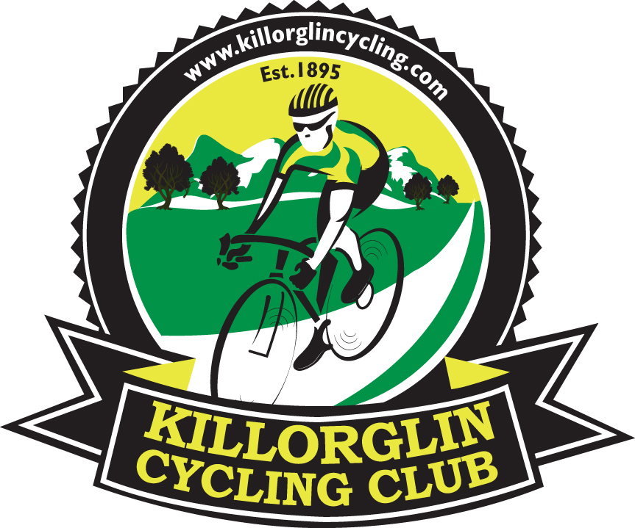

Develop a Cycling Facility in Rangue, Killorglin.

Proposal by Killorglin Cycling Club founded in 1895.
Killorglin Cycling Club has a long history in Killorglin and its name is recognised throughout Ireland for the cyclists it produced like John & Gene Mangan and the events it organised and promoted such as:

- Kerry Youth Tour
- Kerry Group Rás Mumhan

The club would like to propose that a cycling facility be developed with access to everyone.

The town has a strategic position, at the intersection of two National Secondary routes, the N70 and N72. The town is ideally located, central in the county, being the “gateway” to the Iveragh peninsula and on the major tourist routes.

Adaptive Re-Use for old quarry giving it an unexpected second life.
There are minimal facilities available for children and youth in Killorglin and surrounding area. An off road cycling facility would help keep the youth of area active and help with their wellbeing. As more towns throughout Ireland invest in well-connected and safe cycling infrastructure, more people can feel secure when biking, which can create more access to social and health benefits.
This proposed cycling infrastructure is a planned investment for a unified and safe bicycle infrastructure network (local and regional) that’s integrated into the transport system and supports multimodality.

Vitally, we can use this dedicated resource to help implement Government commitments such as the new Safe Routes to School programme by allowing children to safely train offroad to become competent, before they venture on public roads.
This Safe Routes to School programme will ensure that children of all ages and backgrounds can travel to school safely, and in a healthy and active way.
Cycling Ireland is promoting the Get Ireland Cycling (GIC) initiative to get more people into cycling and to encourage cycling as a lifestyle choice.
Everyone would like to drive less or not at all – to save money and help the climate – but Ireland’s rural patchy public transport network has left them dependent on cars.
That is the reality for many people in Ireland, and one reason its greenhouse gas emissions continue to rise, imperilling climate targets.
The challenge is urgent. Ireland’s emissions rose 4.7% in 2021, the Environmental Protection Agency said, exceeding pre-pandemic 2019 levels and casting doubt over ambitious and legally binding 2030 targets. Under sectoral targets transport, the second biggest emitter after agriculture, must reduce emissions by 50%.
Ireland has the fourth highest level of transport emissions per capita in Europe, with private cars the largest contributors. Seventy-four per cent of all journeys are by car and just 7% by rail and bus, according to the Green party.
Investing in cycling infrastructure meets KCC’s need in adapting our investments to the requirements of the EU Green Deal. The European Union aims to achieve climate neutrality by 2050 at the latest which poses further challenges for the Kenmare Municipal Area. This cycling facility would also be economically and environmentally sustainable development according to the criteria of the National Climate Action Plan 2023.
The European Cyclists’ Federation (ECF) believes that bold and visionary investments in cycling transport and tourism are the best way to achieve the above goals and trigger dynamic economic growth of regions, while respecting the natural environment as well as health and well-being of citizens. This belief is based on many years of field experience, hard economic data and scientific research on the health and environmental benefits of active and sustainable mobility. ECF

Funding
There is funding available from the EU. The link below outlines the route for funding via the Multiannual Financial Framework (MFF).
UnlockingFunds_Ireland_final_1.pdf (ecf.com) (49 pages)
In the 2007-2013 EU Multiannual Financial Framework (MFF), approximately EUR 700 million was allocated to cycling.
In the 2021–2027 MFF there is investments budget of € 6 billion available.
In Ireland, the Sustainable Transport Measures Grants (STMG) Annual Report shows €107m of spending in 2020 compared to €39.6m in 2019.
NTA Investment in Cycling Infrastructure Continues to Expand - Transport for Ireland
The ECF has some costings on developing cycle tracks
How much does a cycle track cost? | ECF

Funding may also be sourced from:
- Fáilte Ireland Tourism Capital Investment Programme
- Leader Rural Development Programme provide
The ideal cycling infrastructure include planning investments for a unified and safe bicycle infrastructure network (local and regional) that’s integrated into the transport system and supports multimodality.
Creating a Better Place to Live for locals highlight the importance and reach of the investments made into active travel infrastructure.
More people cycling on the roads of the Kenmare Municipal Region mean lower greenhouse gas emissions, lower noise levels and better air quality, but also greater physical activity for citizens, better health and, what is particularly important in the present circumstances, much lower risk of infection while commuting compared to other means of transport.
Safe Space for Cycling
A modal shift in transport away from cars is needed, bicycles can be used for short journeys and will meet our climate goals.
https://environment.ec.europa.eu/strategy/zero-pollution-action-plan_en
The Cycling Hub would encourage people to train their children to cycle and facilitate more sustainable and healthier travel habits such as cycling.
Cycling Hub would deliver high quality amenity that improves people’s quality of life
Proposed site is adjacent to old railway line and the proposed Killorglin to Glenbeigh Greenway
It is adjacent to Ring of Kerry Cycle Route on L4021, access is on L7504 just 300 metres from L4021
Within 3Km of Killorglin
It is a few kilometres from the Euro Velo 1 cycling route that goes through Killorglin and Cromane.

Urban Cycle Hub: Redefining urban mobility through multipurpose bicycle hubs | ECF
Numerous industrial pits are discarded after their exploitation in every part of the world. Humanity both transforms the original morphology of the landscape, due to industrial activity in the territory, and, at the same time, rejects this situation.
This is to the detriment of the landscape, which is witness to this transfiguration, degradation, and abandonment.
What is the future of these impersonal and empty areas? Renewal with a cycling facility for locals and tourists alike?

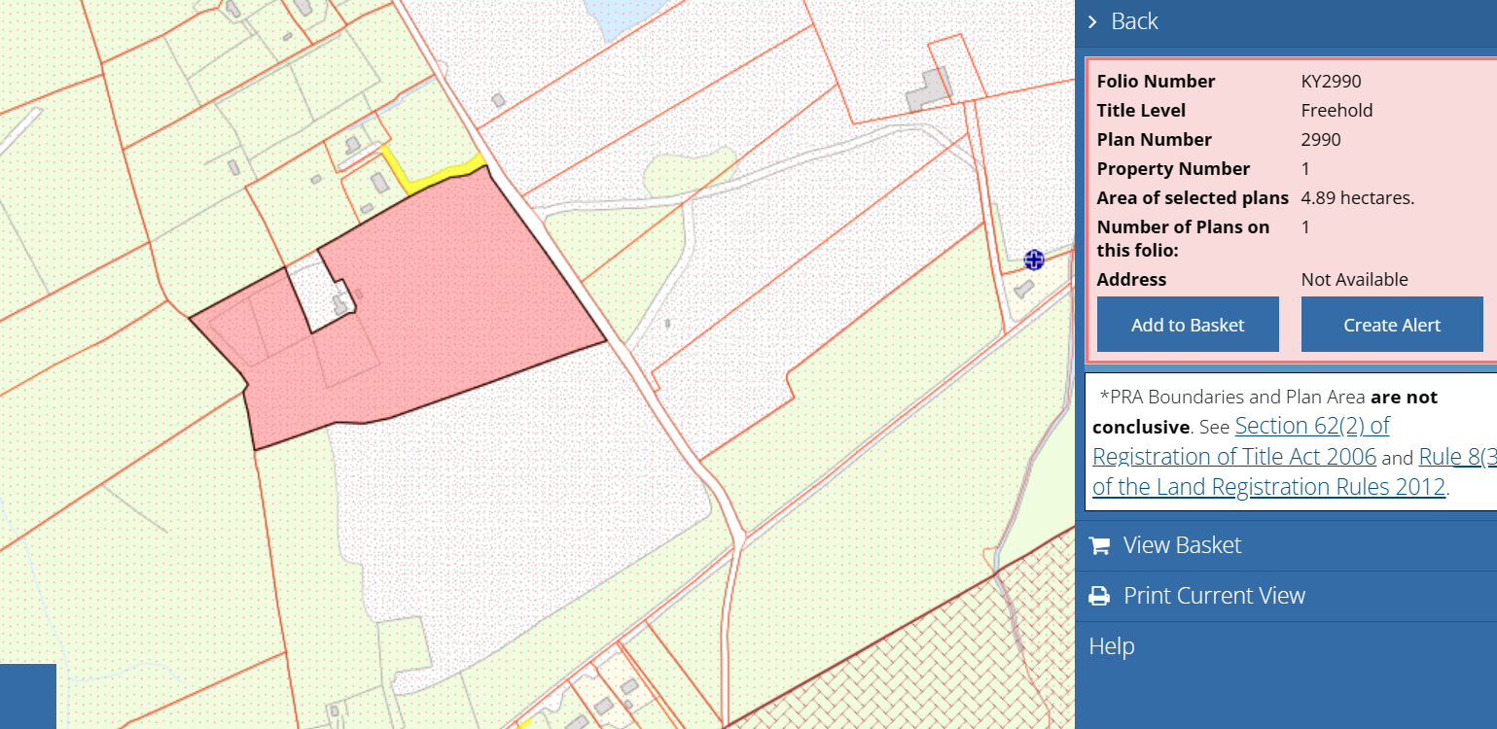
Proposed site for cycling facility. Old Roadstone aggerate pit. {Permission to use their data has been received] Ref: PG.

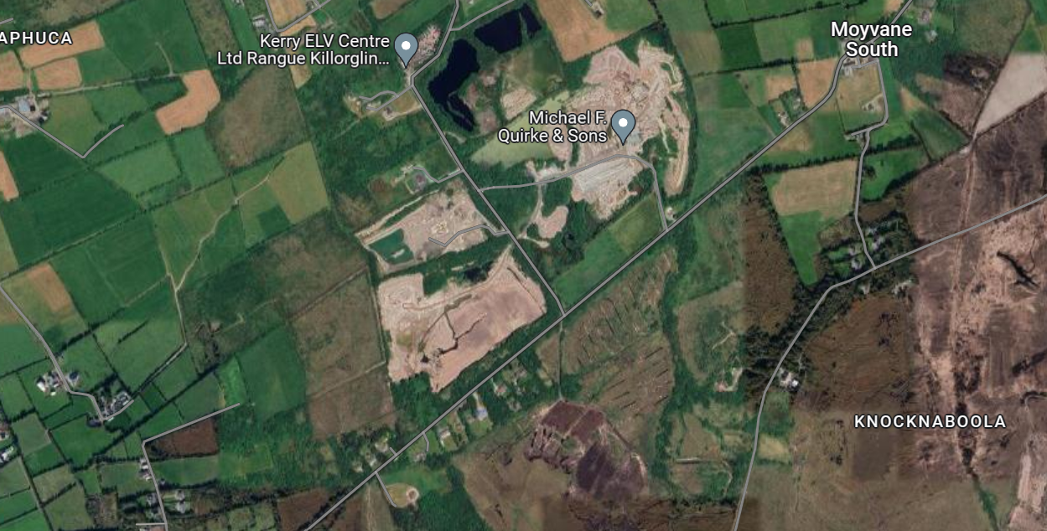
Site outlined in Red. Old quarry site that is at end of life
Unrehabilitated quarries contradict the Kenmare Municipal Area development goals and possibilities: they pose hazardous effects to humans, animals and the environment. Moreover, economic activities and employment opportunities are left out of sight – concepts that make the core values of creating a sustainable and resilient Killorglin and Kenmare Municipal Area.
The Cycling Hub Blueprint has been developed by Cycling Ireland as an overarching guide for coordinated planning and development of cycling hubs across Ireland. It provides a vision, guiding principles and cycling hub development options for consideration by local authorities, land owners, clubs, schools and the community.
Click on link below to read Cycling Ireland blueprint document (44 pages)
15.12.21CyclingIreland-CyclingHubsBlueprint.pdf
The blueprint explains how different sites and local amenities can accommodate the creation of cycling hubs without significant capital investment.
Examples of current cycling facilities throughout Ireland on link below:
Find a Cycling Facility | Cycling Ireland

Sustainable development
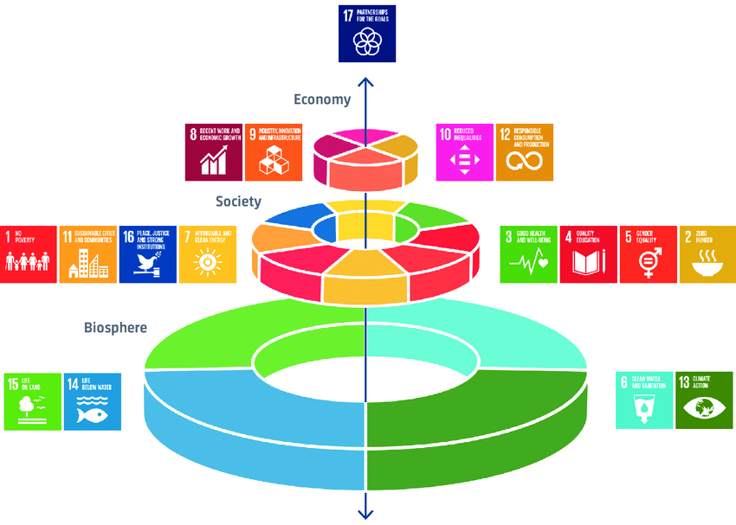

UN Sustainable Development Goals
The development of cycling infrastructure will enable the area to be more resilient and meet the UN Sustainable Development Goals especially SDG 11: Sustainable Development Goal 11 (SDG 11) – making cities and human settlements inclusive, safe, resilient and sustainable.
Ref: SDG11_Brief.pdf (unep.org)

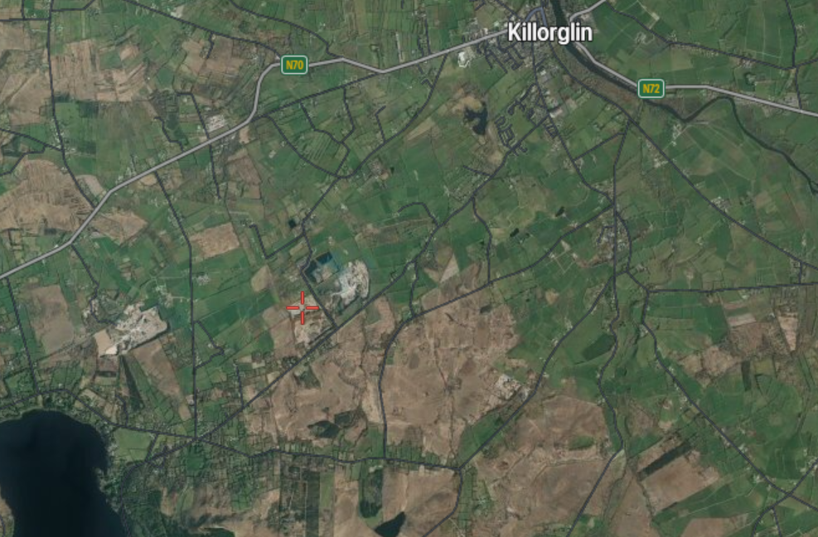
Red cross shows proposed site approximately 3km west of Killorglin.
Yellow line shows position approximately of where old Great Southern rail line is situated.

Kerry Tourism Strategy and Action Plan 2016 - 2022
This proposed development of a cycling facility complies with action 2.2.4 of Tourism Strategy and Action Plan 2016 – 2022: Develop & promote further the cycling product in cooperation with the local cycling clubs
TourismStrategy.pdf (kerrycoco.ie)
Killorglin and the Reeks District are trying to promote itself as a destination and Killorglin needs a range of Activities & Amenities to do this! Killorglin has the mountains and the ocean nearby but there are few Activities & Amenities in the area for locals or visitor.
The 5 A’s of Tourism: These are five factors that create the perfect travel destination and draw in visitors every year.
They are:
- Accessibility
- Accommodation
- Activities
- Amenities
- Attraction
A Cycling Hub would be a major attraction for the Reeks District and Kerry.
Destination amenities are found to be the core determinants of the attractiveness; destination support facilities and services, and people-related factors are the secondary determinants.
The attraction would extend the tourism season across the county but, in particular, in the Killorglin area, where the tourism season is short.
Other ideas for this space include: Provide an outdoor gymnasium, climbing wall or running track in this area.
The Government’s tourism policy document Policy, Place, People (2015) projects an annual increase in overseas tourism revenue of 5% per annum in real terms until 2025. The cycling facility would extend the season locally and provide for both visitors and locals alike.

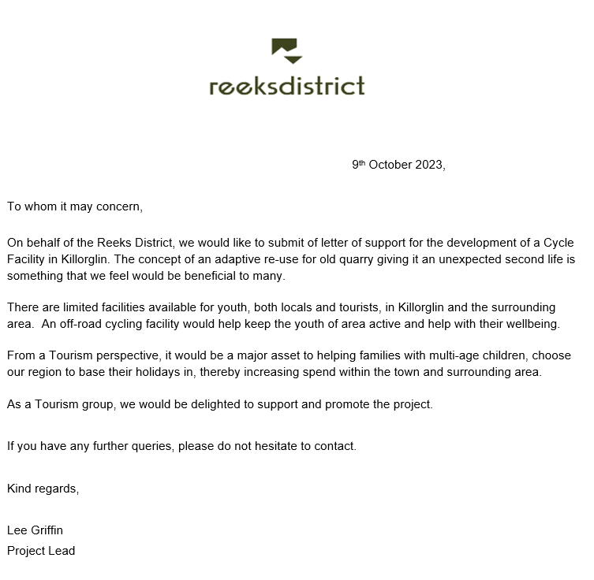

Another possible site for a cycling and running track is to build a track on perimeter of the land at rear of the Sports Complex, Langford Street. This land is owned by Kerry ETB.
A circuit of circa 800m could be built in its perimeter. Cost circa €300K.

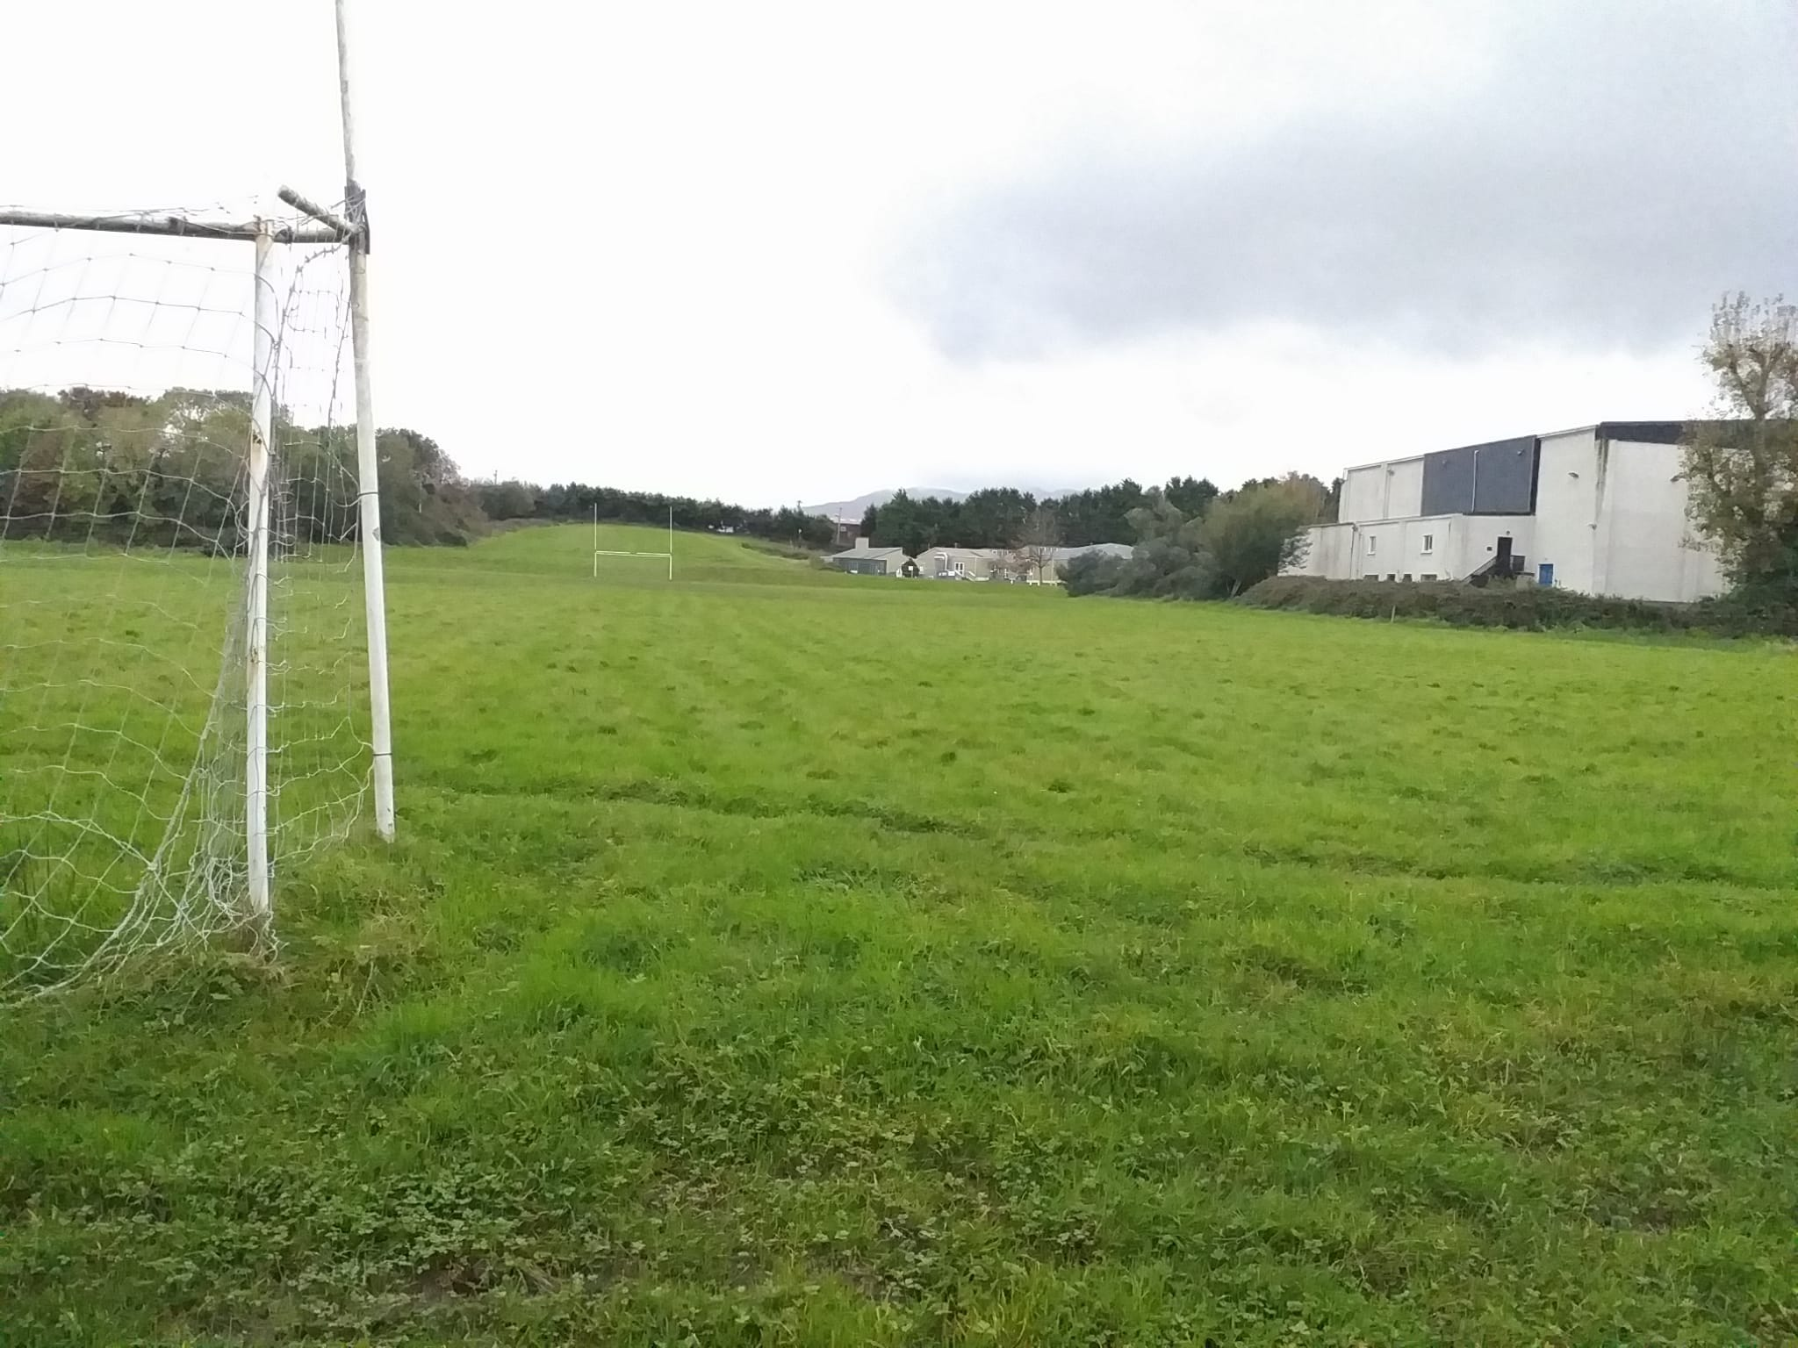

Big Belly Bins
There is a need to increase capacity of the available bins in Killorglin. They are often full on weekend evenings as they are emptied in weekend mornings but are full again by late afternoon.
The litter is a threat to our environment as it can be washed away and enter the storm drains and the enter the river Laune which is a SAC. The is in breach of the Water Framework Directive. It then becomes marine litter.
Definition
Marine litter (also called marine debris) is defined by the National Oceanic and Atmospheric Administration as “any persistent solid material that is manufactured or processed and directly or indirectly, intentionally or unintentionally, disposed of or abandoned into the marine environment” (NOAA 2018).
The majority of marine litter, up to 80% found in surveys, consists of plastics (UNEP 2016b). Marine litter pollution is a complex worldwide environmental problem with diverse marine and land-based sources UNEP 2016a, UNEP/NOAA 2011).
BigBelly bins are an example of new technologies that the average person knows little about. The bins first appeared on Trinity College’s campus in 2008 and were later rolled out throughout the city in 2017. With a solar panel on top and a large opening flap, these bins tower over the simple plastic bins Dublin was used to.
Dublin’s smart bins find new purpose during the pandemic - Council.ie
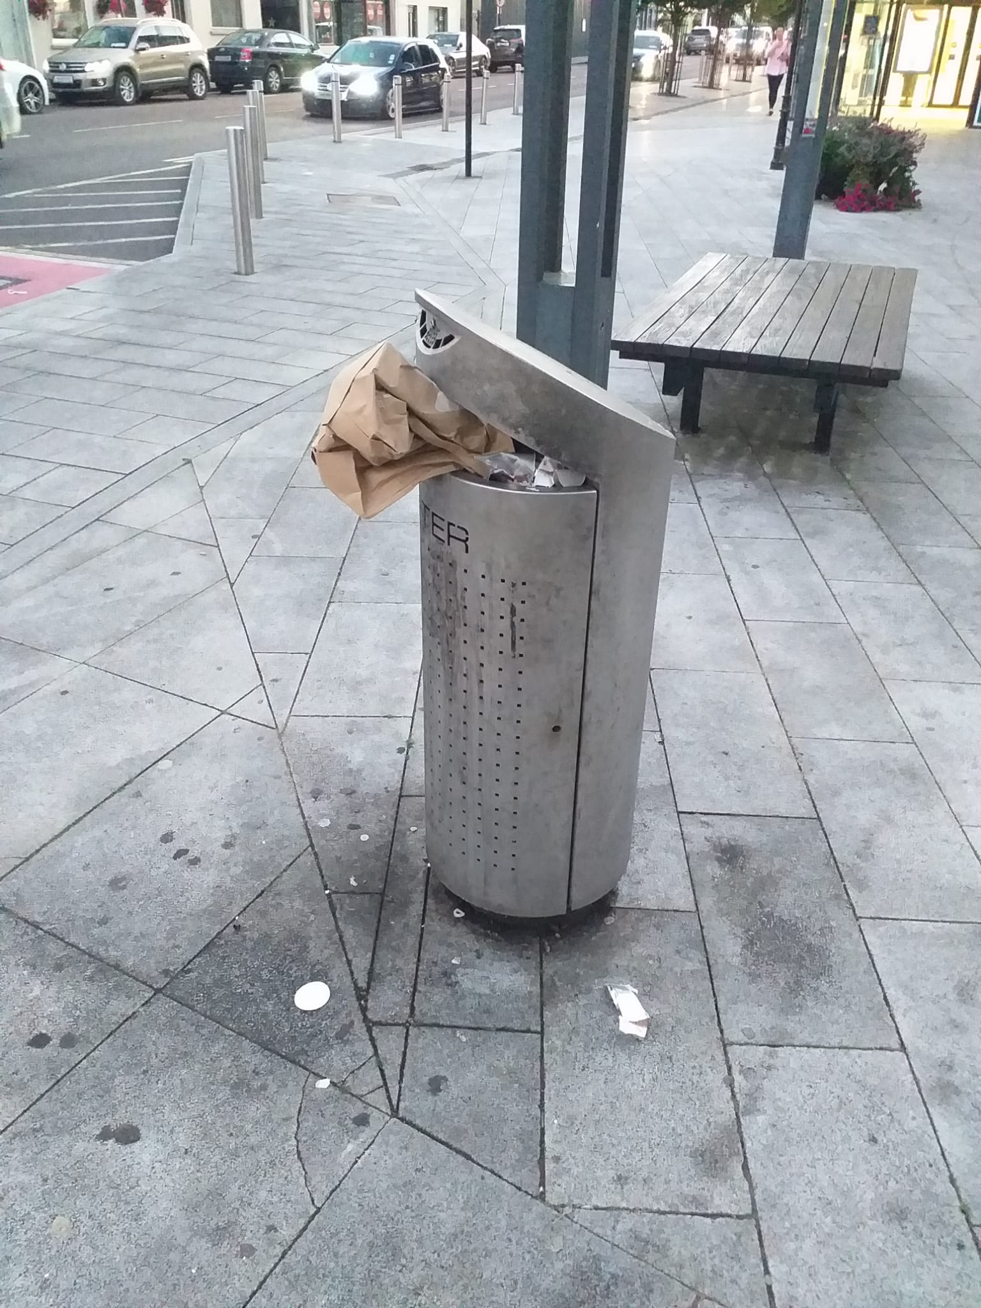
Picture of bin in Library Place on a sunny Sunday September evening.

New solar-powered ‘Big Belly’ bins have popped up all over Cork, Dublin and Laois to solve litter issues there. In 2022 Cork City Council had 54 brand new solar compacting bins installed around Cork city centre to help keep the streets clean.

Examples from Dun Laoghaire
Street Bins | Dún Laoghaire-Rathdown County Council (dlrcoco.ie)
https://www.dlrcoco.ie/litter-control-cleansing/street-bins

https://www.yaycork.ie/new-solar-powered-big-belly-bins-have-popped-up-all-over-the-city/
Cost:
There is funding available under the Litter Infrastructure Support Grant Scheme from the Department of Environment, Climate and Communications.
Each unit costing circa €6,000
Benefits:
- They hold up to eight times more rubbish.
- Just eight hours of sun provides compacting power for one month.
- Using a sensor, these state-of-the-art bins determine the amount of waste in a bin and compact the waste, when required, to provide more holding capacity.
- When they are ready to be emptied, they send an electronic message to council staff. This new technology will mean fewer collections, lower collection costs, and fewer emissions.
- In addition, the fully-enclosed design means they are bird and vermin-proof, can be operated using a foot pedal, and provide data on which streets generate the most binned litter.
- Cost and labour savings would come from the cutting of staff labour, provision of vehicle fuel, PPE and materials.
- According to South Dublin County Council, the trial of the big belly solar bins in Rathfarnham Village showed that on average the servicing of litter bins can be reduced by as much as 85 per cent.

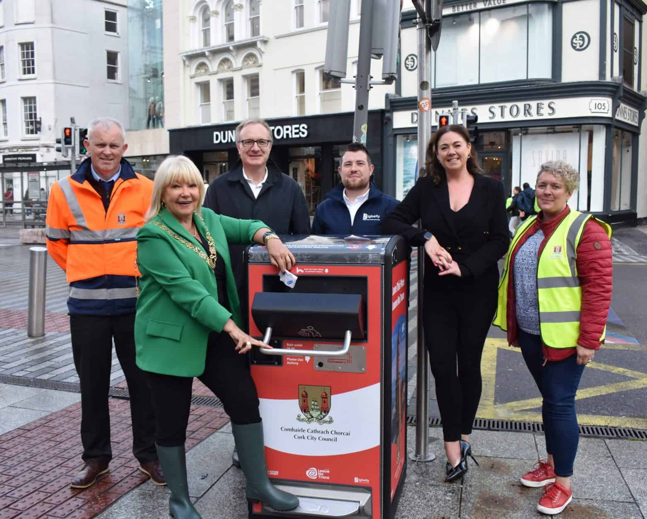
Image from: https://www.yaycork.ie/new-solar-powered-big-belly-bins-have-popped-up-all-over-the-city/

Gullies
The two (2) main issues in town are
- Silted up gullies mainly on N70, over 2km of this road has inaccessible gullies
- Some Gullies are without a sump to catch the silt and litter

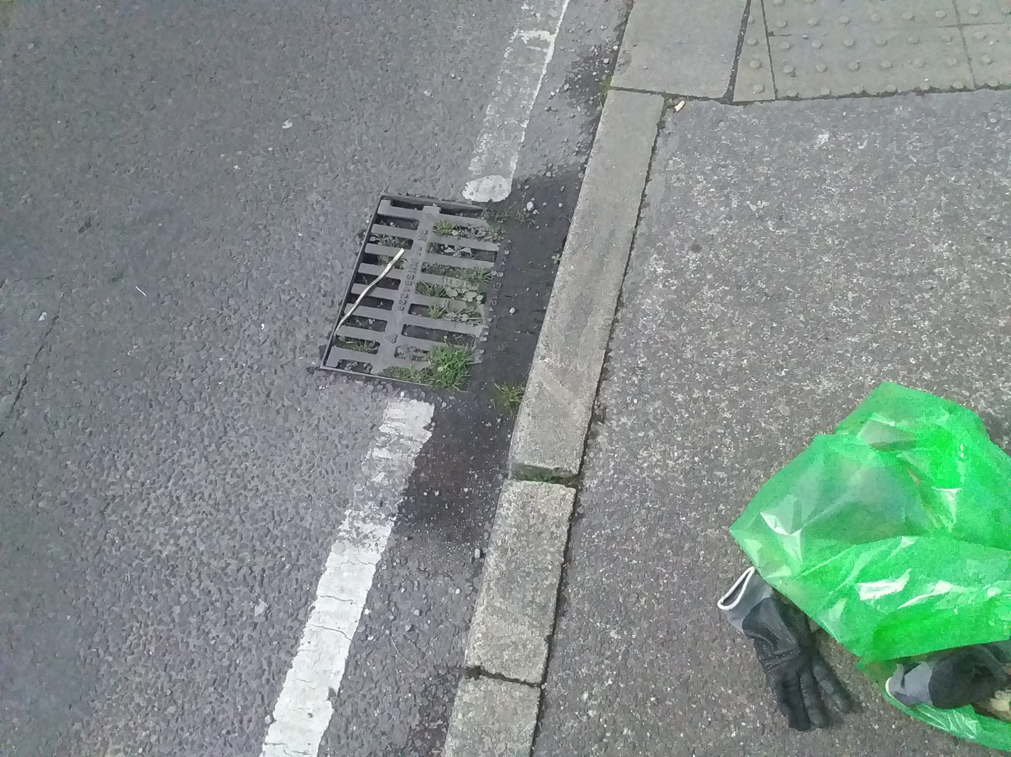
Example of silted up gully, Iveragh Road, Killorglin
KTTG clean out any accessible gullies in town centre on a regular basis, its outside our remit but they get clogged up quickly.
Pollution due to heavy rains and resulting urban runoff represent a sizeable source of loads sent to the river Laune which is a Special Area of Conservation (SAC).
The EU Water Framework Directive (2000/60/EC) requires all Member States to protect and improve water quality in all waters so that we achieve good ecological status by 2015 or, at the latest, by 2027. It was given legal effect in Ireland by the European Communities (Water Policy) Regulations 2003 (S.I. No. 722 of 2003).
These defects in the towns gullies means that they are a failure point in meeting the requirements of EU Statutory Instrument’s and Directives.

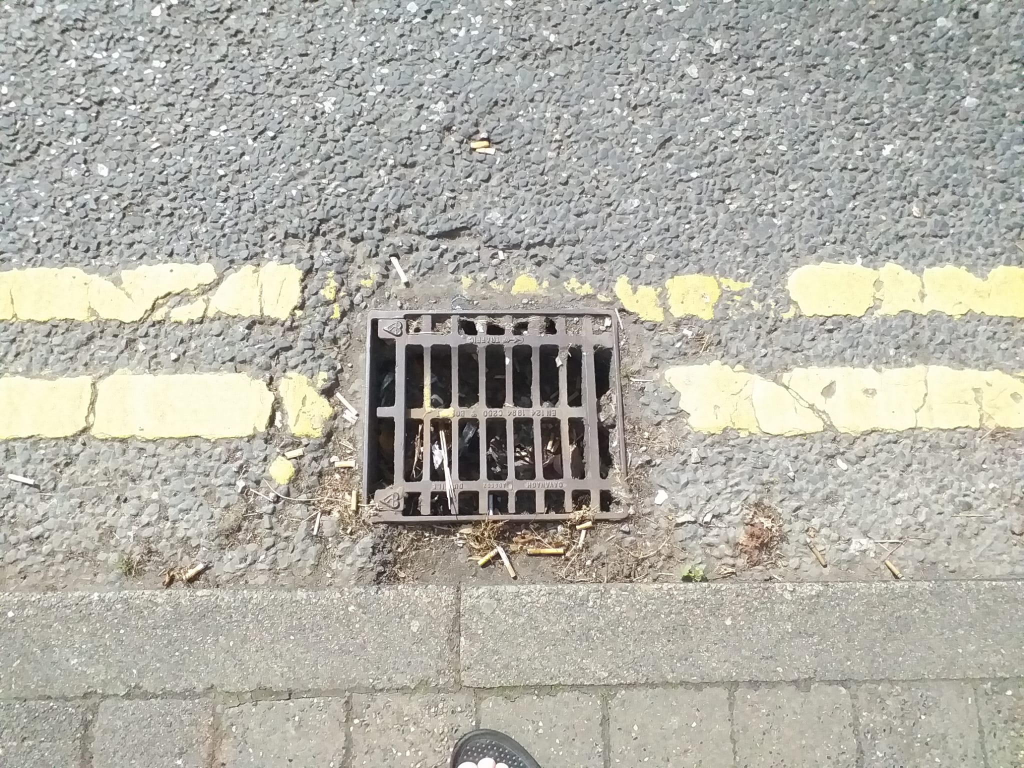
Gully has no silt trap. So urban litter gets into the river Laune this gulley is outside Eurospar

The impacts and risks of climate change are becoming more complex and harder to manage. Here in Killorglin and in the surrounding areas, the community have experienced these impacts, particularly through floods and storms, and the damage they have caused. But these weather events, and their expected increase in frequency and intensity, highlight that we must work to ensure that the basic infrastructure is functioning correctly.

Air quality in Killorglin
The LAP aims to protect Air Quality and the objective states:
AQ1: Protect local air quality from emissions that are harmful to human health and the local environment
Indicators (over the lifetime of the plan)
Air quality trends from real-time data on the number of days / Percentage change in number of days annually air quality levels exceeded EU air quality regulations for monitoring station

There is no Air quality monitoring in Killorglin by KCC or EPA, so without any data how is the health of the community being monitored and protected or where is Air quality in Killorglin town at in respect to EU & WHO guidelines?
Where is the data coming from if KCC is to use Extrapolation for Killorglin’s town information?

Road signs

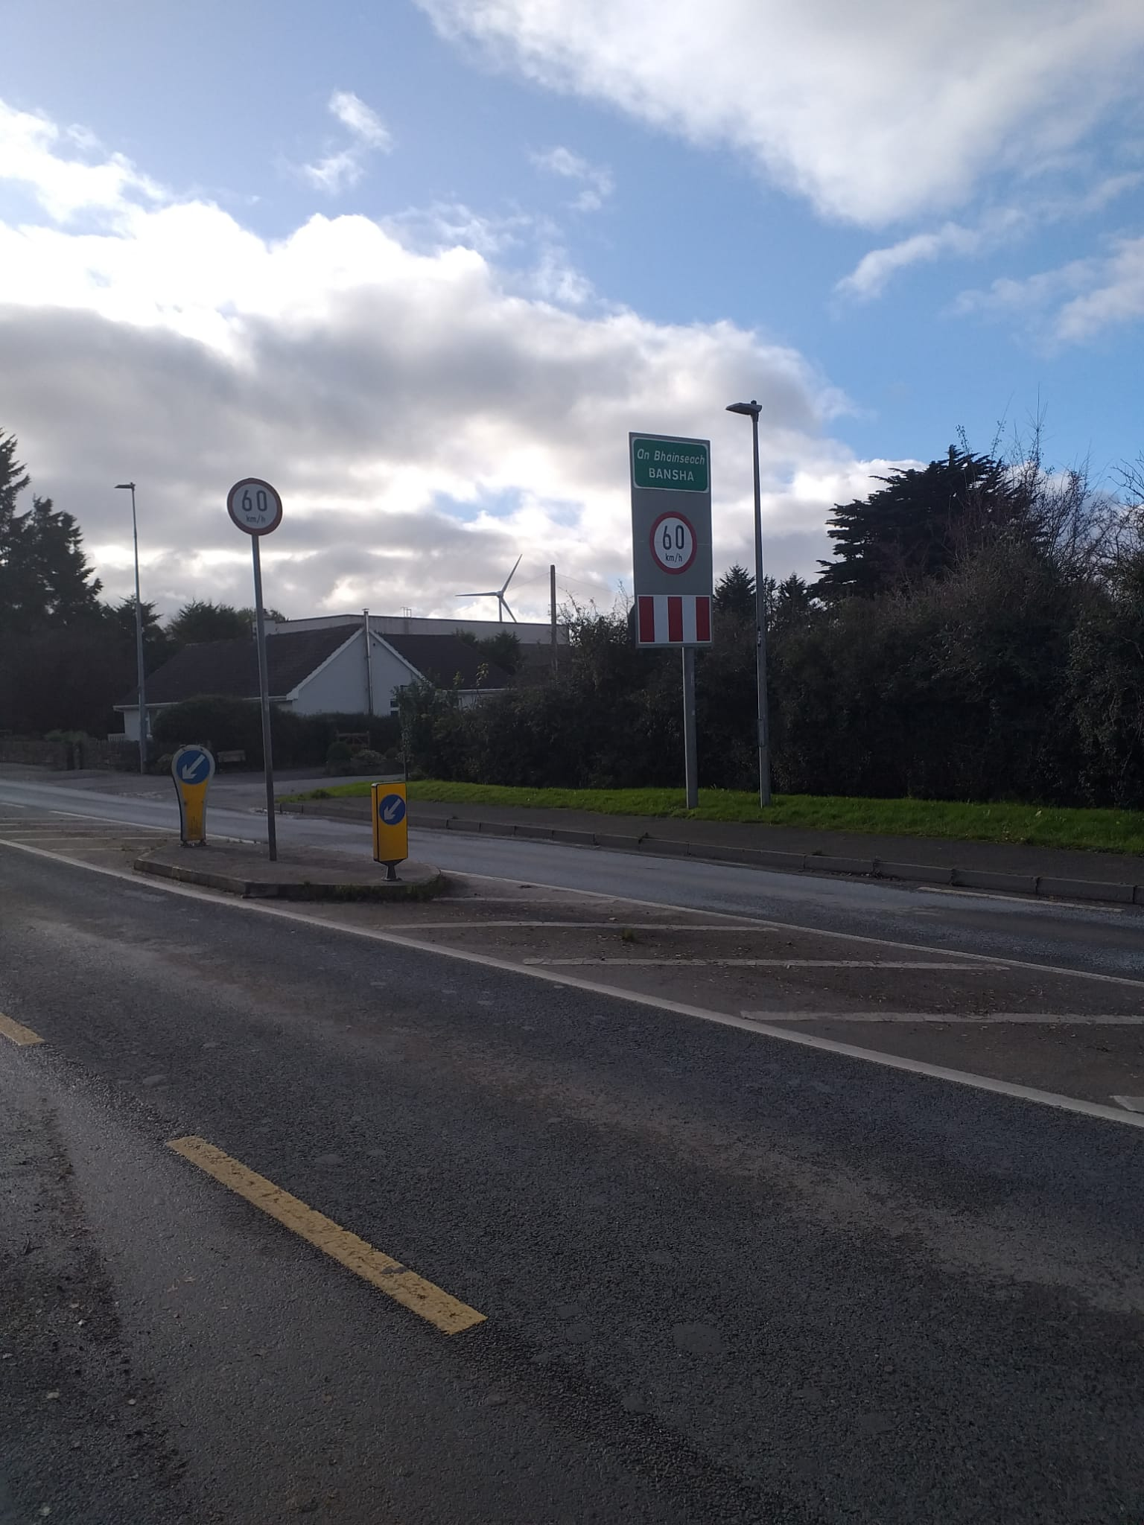

The Bansha road sign on the Milltown side of Killorglin (N70)) is totally confusing to visitors!
They expect to be approaching Killorglin? Even the Tidy Towns adjudicator commented on this a few years ago but no action was taken by KCC.
The sign would be at home in the small village of Bansha, Tipperary. Bansha is located on the National Primary Route (N24) linking the cities of Limerick and Waterford and is eight kilometres south-east of Tipperary Town and thirteen kilometres north-west of Cahir.

