Case for the improved recognition of Fort Shannon in the County Development Plan.
Donard de Cogan PhD, CEng, FIET

Introduction
Fort Shannon is an artillery emplacement which was constructed by Irish army engineers at Ardmore Point between August and November 1942. My late father was one of the officers who oversaw the project. Full details of the political background as well as its construction can be found in https://www.dropbox.com/s/r8jaefehhir43z8/FortShannon.pdf?dl=0 This document advances the argument that it is something worth preserving and that this should be recognised in the County Development Plan

Background
The return of the Treaty Ports in 1938 was much criticised by Winston Churchill in spite of the fact that they did not have the relevance that they had had at the end of the first world war. Shortly after their return it became obvious (in an era of blitzkrieg) that there was much in British military philosopy that had not kept pace with developments, and new approaches had to be developed very quickly. So, during the second world war that part of Ireland referred to as the Irish Free State assumed a quite different, but even greater significance for the Allied cause. The following points should be considered.

1.
The exclusive provision of weather information to Britain and later to the USA was a major factor in what was called "The Weather War". By denying Germany ready access to Atlantic weather conditions it would be possible to hamper the bombing of UK cities. In order to acquire this information Germany had to deploy U-boats at specific locations and a U-boat acting as a weather station was a U-boat that was not sinking Allied shipping. Just before the war two countries were asked to provide Britain with exclusive access to weather information. Iceland refused and was invaded by British forces in May 1940. On the other hand, Ireland agreed to this request and censorship was maintained at a level where, for instance a radio commentator at a race meeting such as Leopardstown was prohibited from commenting on the state of the turf in case the Germans might infer the state of the weather.
https://www.dropbox.com/s/xz9s2pqv581bmvi/WeatherBookFinal.pdf?dl=0
And, of course there is the weather report from Belmullet which prompted the green light for the Normandy Landings
(https://www.rte.ie/news/2021/0619/1229119-maureen-sweeney/)

2.
The flying boat base at Foynes was not only used for tran-Atlantic flights, but was an absolutely essential link for Britain. Personnel returning from Egypt and further east could get safely to Gibraltar and from there to Lisbon. However, if a flying boat flew straight back to Britain, it risked being attacked by German aircraft stationed in France. Accordingly flights from Lisbon took off at night and flew into the Atlantic on a wide loop to land and re-fuel at Foynes in the morning and from there they returned to UK. The safety of all such flights and flights from North America required accurate weather information. The meteorological station at Foynes, as well as Foynes itself were under Irish military guard.

3.
Ireland agreed to the provision of visible navigation beacons such as EIRE 7 at Dalkey
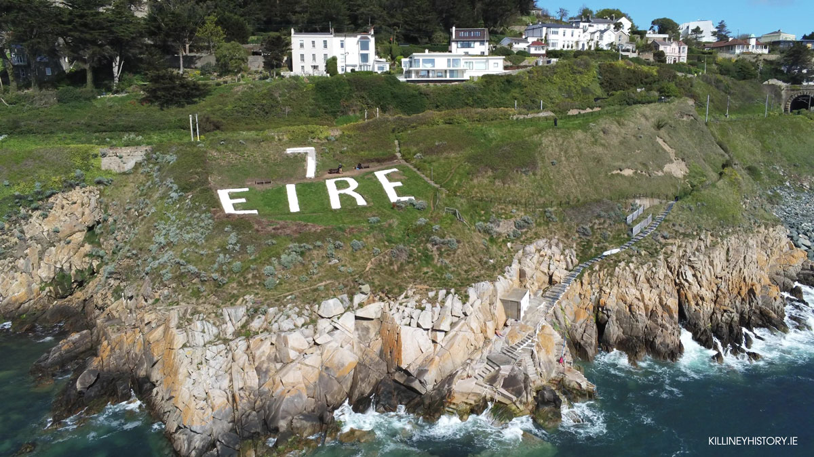
This had been obscured by overgrowth in excess of seventy years and was restored by local effort shortly before the Covid pandemic

The strategic importance of Fort Shannon
If Germany had chosen to attack the flying boat base at Foynes it would have been disastrous for the Allied cause and it was in recognition of this fact that Churchill sanctioned the donation of two six inch guns plus 110 rounds of ammunition for each to be used for the defence of the Shannon.

The artillery emplacement at Ardmore Point, known as Fort Shannon represents something of which Ireland should be proud and should seek to preserve. It represents a remarkable example of strategic planning and construction. Any hostile warship entering the Shannon would have to travel south of Scattery Island on account of their draught and while transiting this narrow channel, would have been restricted in their ability to manoeuvre. In this circumstance they would have been seen as a 'sitting-duck' by the strategically placed guns at Ardmore Point. The location is remarkable on account of it geography, since only the guns and searchlights would be visible to the hostile intruder. All the critical infrastructure is obscured by the reverse bank. Additionally, the guns are situated at different ranges and elevations so that if one had been knocked out by a lucky shot, then the gun-layer on the vessel would not have had the convenience of a simple traverse to hit the other one.

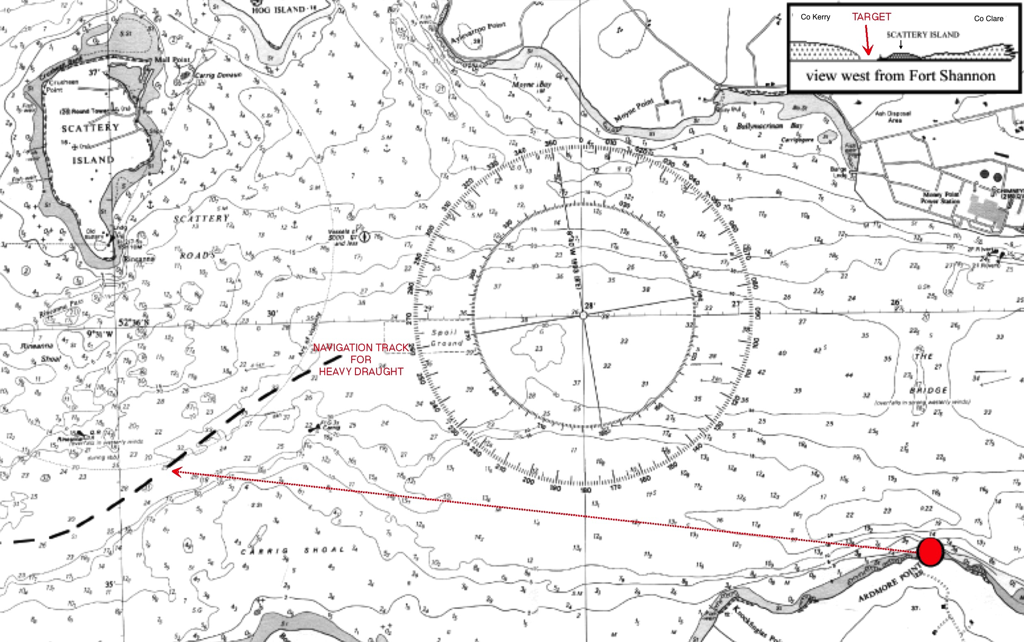
This marine chart for the lower Shannon shows the navigation channel which a heavy draught vessel would have had to take south of Scattery Island (broken black line). The red dot on the bottom right shows the location of Fort Shannon at Ardmore Point. The small insert on the top right shows a view west from Fort Shannon with the Kerry coast on the left, the Clare coast on the right and a small gap between Scattery lighthouse and the land to the south. Any intruding vessel would have appeared as a silhouette in this gap - a sitting duck target.

In summary
Everything about Fort Shannon is pure genius and was designed and built by Irish Army engineers. I believe it to be unique in Irish military history and I contend that it must be preserved.

In this context it has been drawn to my attention that a part of the Fort Shannon site on the western side (which I understand is still in the possession of the Department of Defence) and which is not currently part of the Special Area of Conservation is proposed to be zoned for industrial development. I would strongly urge a reconsideration of this situation to ensure that the integrity of the entire ensemble is maintained for the benefit of future generations who might view this remarkable piece of Irish military engineering with immense pride.

