Feabhra 2022 - CFCD - Aighneacht ar dreacht CDP Ciarraí 2022 - 2028.

Executive Summary
The commitment towards the Gaeltacht and the Irish language in the draft CDP is welcome. There is a lot to build on. In our view there are opportunities to make the CDP stronger and more effective in supporting the language and the Gaeltacht community. Some new challenges in the post-pandemic society need to be considered. We are recommending revisions to the draft plan, in particular:
- Greater emphasis on integration of language planning and physical planning.
- Recognition of the particular housing challenges in the Gaeltacht.
- More supportive policies for rural housing for Irish speakers.
- Addressing the need for affordable housing for Irish speakers.
- A more cautionary approach to housing estate development.
This submission sets out our position, and in Appendix A we set out specific recommendations for revision and improvement of the draft CDP policies.
- Common Ground
We share the objectives of the draft CDP in relation to protection of the valuable landscape and environment of the Gaeltacht areas. We are also concerned about the proliferation of vacant holiday homes, which do not add to the year-round vitality of the Gaeltacht. We accept that sensible siting and design of rural housing is the right approach, and that developments must respect the need to protect traffic safety and groundwater. We share the vision for a vibrant and lively Gaeltacht.
“It is the policy of Kerry County Council to preserve and promote the use of Irish as a living daily-use language and Gaeltacht communities will be supported in order to strengthen and expand the social networks that nourish Irish as the community language”
Draft CDP December 2021: Section 8.1

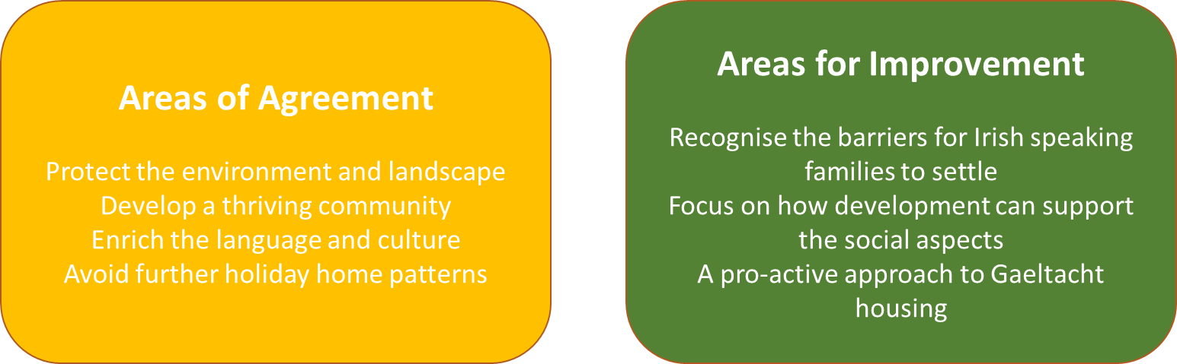

- Recognising language in Physical Planning.
Are there better ways to enhance the language when it comes to planning ? In the Irish planning system, special rules are followed for protection of natural heritage (for example, for a development proposed close to an SAC) and for protection of the built heritage (for example, a development of a protected structure). The planning systems integrates heritage protection and enhancement in the assessment of the case. Input from specialist ecologists and conservationists is considered. The planners train to understand the subject. It is time for us to think of language heritage in the same way.
Planning applications in the Gaeltacht should be subject to specialist language assessment (in the same way as ecology or conservation specialists advise on natural or built heritage). The Gaeltacht language planning officers should be central to this process. They can advise on whether a proposed development will strengthen the language in the community, or weaken it. Impact on language needs to be integrated into the overall assessment process, and not be seen as a separate or isolated consideration.
The draft Plan of December 2021 refers to statistics on demographics, and the success rate of planning applications, but we feel the focus needs to be more on how planning outcomes relate to use of language and social aspects. A fall of 19% in the use of Irish between 2011 and 2016 is a serious concern.
Sustainable Rural Housing Guidelines, 2005, DEHLG
“Give special consideration to the effects of new development in Gaeltacht areas on the survival, use and development of the Irish language as a means of daily communication.”
Kerry County Council can give stronger effect to this national policy in its CDP 2022-2028, including greater support for development that will be positive for the language.

- Particular housing challenges in the Gaeltacht
In the Kerry Gaeltacht areas, the desirability of the scenic landscape and richness of the environment means that property prices are high. Availability of housing is low. For people employed locally who may be earning modest salaries, buying a second-hand house in the Gaeltacht may be impossible. If Irish speakers and particularly younger people and families are ‘squeezed out’ this will have a negative impact on the language. The CDP should recognise this concern because it relates to the physical planning of the Gaeltacht. A more pro-active approach is needed.

- Planning policies in the CDP can support Irish speakers to build their community network
Building a critical mass for spoken Irish is a multi-dimensional challenge. Physical planning is an important factor. Things that are good for daily use of Irish include:
- Families living in proximity – this helps the intergenerational language transfer between grandparents, parents and children.
- Settlement patterns that foster a sense community – proximity enables networks and support structures that lead to daily interactions through Irish.
- Connection to place – being able to connect with the natural heritage, folklore and oral tradition of an area, by living in the area.
We encourage KCC to give greater weight to these aspects when considering physical planning of housing in the Gaeltacht.
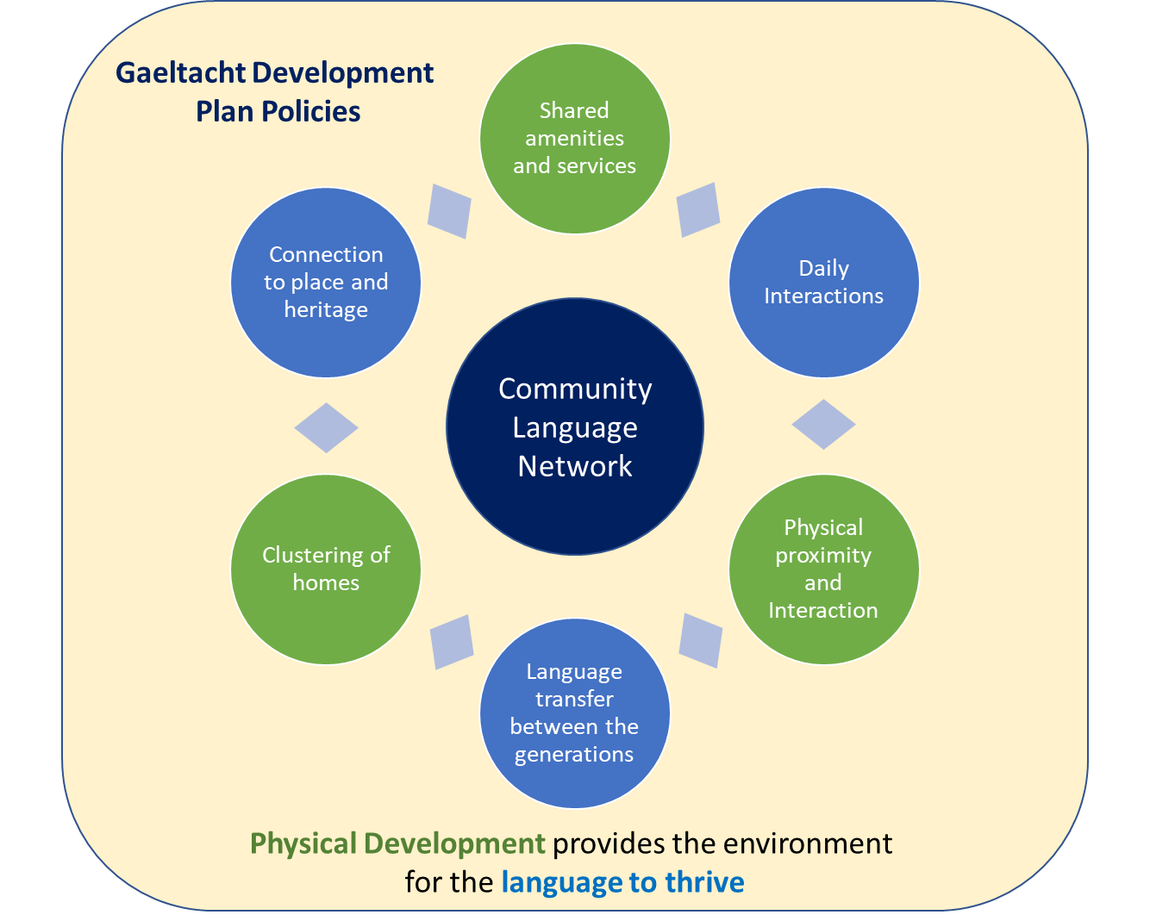
- Frustrations felt by Irish speakers
During the last CDP period, a number of Irish speakers have had frustrating experiences with the planning system when seeking to build rural houses in their community. In some cases, a lot of time and money has been spent trying to demonstrate a ‘local need’, select a suitable site, carry out soil tests and develop a suitable design, only to receive a refusal of permission. Of course, the refusal is not on language grounds, but for those who are committed to keeping the language and culture alive, the bad outcome can feel like an insult to the language and culture itself. Rather than find ourselves playing a blame-game, we need to find ways to work with KCC to avoid this kind of outcome.

- A more effective pre-application process
A more effective pre-application process can help avoid unnecessary cost and delay. Language considerations should be central to this process. We urge a positive approach towards Irish speakers proposing to build in Gaeltacht areas. This does not mean that normal good planning practice (landscape, public health, traffic etc.) is not followed. It means recognising the benefits this development will bring in relation to the language, and providing advice and guidance on how to develop a high-quality application. Equally, advice should be clear when a development is unlikely to be successful, so that applicants can re-consider their options.
- Learning from other County Development Plans
In 2020 CFCD commissioned an expert report by Doyle Kent Planning Partnership that examined Gaeltacht planning policies at national level. This report confirms that positive and effective policies are in place in some Gaeltacht counties (refer to Appendix B for selected references). In our view, Kerry can follow a more supportive approach in the final CDP 2022 – 2028. A revision to the policy of Section 5 of the draft CDP in relation to rural housing policy is proposed.
- Post Pandemic Society – challenges and opportunities for the language
As we emerge from the Covid-19 Coronavirus pandemic, new pressures are being felt in the Gaeltacht. There are positive and negative aspects. Some native Irish speakers are wishing to relocate from urban areas to the Gaeltacht, bringing vitality to the area and increasing the population (and hopefully supporting schools, sports clubs and so on). The flip-side to the telecommuting pattern is a greater demand for scarce housing, and the potential for local people earning modest salaries to be squeezed out of the housing market. This increases the need for a positive and responsive approach to additional rural dwellings – particularly for Gaeltacht natives who may otherwise not be able to live locally – and for social and affordable housing for Irish speakers. This will enable the Gaeltacht to grow stronger particularly for younger people and young families.
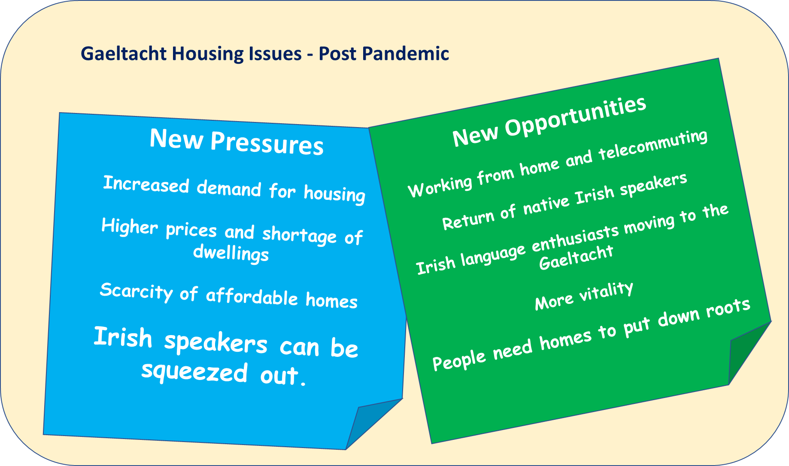

Part of the solution here may be to encourage new, more sustainable forms of dwelling and settlement: an emphasis on smaller, more sustainable homes is to be encouraged. Refurbishment of derelict or disused dwellings is also to be encouraged; we would urge a positive and flexible approach from KCC for such applications, bearing in mind the multiple benefits accruing.

- Addressing the affordable housing deficit
We would urge a reconsideration of the social and affordable housing policies for the Gaeltacht areas. In response to the high cost of housing in the Kerry Gaeltacht (see above) a more pro-active approach is required. If native speakers can’t access housing in their own area – which is by and large rural – and need to re-locate outside the Gaeltacht to find affordable homes, there will be a loss of language resource and critical mass, particularly for the younger generation. We recognise that opportunities to buy land for public housing appear to be limited, but if KCC are committed to the Gaeltacht as set out in section 8.1 above – strengthen, expand, nourish – this needs to be demonstrated in practice by making more social and affordable homes available that will nourish the language.
“It is important that the County Development Plan supports the Irish language and that the policies contained within the plan are broad and wide-ranging enough to facilitate any future strategies and initiatives that seek to sustain and augment the daily use of Irish”
Draft CDP December 2021: Section 8.1
It might also be considered that the building of rural housing on family land is in effect a form of affordable housing, because it enables local Irish speaking families to develop a home that might otherwise be unaffordable.
- A cautionary approach to housing estates/multi-unit development
Despite the best efforts of the planning system, and the attachment of planning conditions restricting housing to Irish speakers, it would appear that many estates in villages and towns in the Gaeltacht (throughout Ireland) have low levels of spoken Irish on a daily basis. We would urge a cautionary approach to larger residential development, whereby a careful assessment of language impact is carried out – including input from language planning officers – as an intrinsic part of the assessment of the application. We should ask: will this development enhance the language ? Scale is important and where multiple units are proposed, smaller scale clusters are preferable to large estates.
We agree with the attachment of planning conditions restricting sale/ occupancy to Irish speakers meeting the TEG-B2 standard or higher in spoken Irish, but this is a safeguard and should be secondary to the decision in principle.

Appendix A
Proposed revisions to the published draft Development Plan of December 2021

Additional proposed text is highlighted in yellow and placed in a text box.

Chapter 8 Gaeltacht Areas Culture and Heirtage

Cover Image: We suggest that an alternative image (or an additional image) be used reflecting the Gaeltacht/ Irish language.

Section 8.1
The population of the Gaeltacht areas in the county increased marginally from 8,729 in 2011 to 8,756 in 2016, but the number of daily Irish Speakers declined by 19 % in the same period.

Section 8.1.3 Preservation of the Irish Language
The main factors that need to be considered in the preservation of the Irish language (within the context of this land use plan) are social aspects, demographics, economic factors, facilities, and infrastructure. Social aspects include settlement patterns, connection to place, and proximity of family and community networks.

(Social aspects are equally as important as demographics which on its own is a limited yardstick for the language: In the last intercensal period, population was unchanged but Irish speaking diminished).
We do not question the accuracy of the following passage, but it may be preferable to address the two issues of planning success rate and holiday homes separately and cast a more positive approach for the future. “Kerry County Council actively facilitates those individuals with an intrinsic and economic need to live in the rural Gaeltacht area. Between March 2015 and June 2021, 71.4% of all rural one-off housing planning applications were granted in the Corca Dhuibhne and Uibh Rathaigh Gaeltacht. However, it must be noted that according to the 2016 Census (CSO) there are 2,068 holiday homes in Gaeltacht areas representing 32.5% of Gaeltacht housing stock. In some rural ED’s over 50% of the housing stock comprises of holiday homes. The pressures of such development and associated migration of non-Irish speakers have the potential to affect the viability of the Irish language.”
Suggested revision.
While the majority of applications for rural housing in Corca Dhuibhne and Uibh Rathaigh (over 70%) were successful during the period March 2015 – June 2021, the pressure for new housing creates challenges for protecting the landscape and environment. All applicants including Irish speakers must comply with the requirements of good planning practice as set out in the Development Plan. Renovation of old or derelict dwellings, and more sensitively sited, scaled and designed housing, are ways to reduce the impact of new development. The pre-application planning consultation should be used to reduce the risk of delay or unsuccessful applications.

According to the 2016 Census (CSO) there are 2,068 holiday homes in Gaeltacht areas representing 32.5% of Gaeltacht housing stock. In some rural ED’s over 50% of the housing stock comprises of holiday homes. Holiday homes, often empty during many months of the year, add little to the long-term vitality of the language, and they ‘soak up’ the capacity of the landscape for additional housing.

8.1.3.1 Irish Language Policies
“Demographics – A sufficiently large and young population is needed to maintain the vibrancy of the language.” We suggest that this be revised and expanded as follows:
- Social aspects and demographic profile: opportunities for daily use of Irish (e.g. in education, sport, cultural pursuits) and for inter-generation transfer of language, and a young and growing population can bring vibrancy to sustain the language.
- Settlement Patterns: physical development that brings Irish speakers closer together and sustains daily interaction in the community.
- EconomicFactors (etc.)

“Therefore, it is of critical importance to maintain the proportion of active integrated Irish speakers above 67% and ensuring that the proportion of young people speaking Irish is increased. It is the policy of the council to: (add new bullets)
- Work collaboratively with the Gaeltacht community in the planning of housing and other development by engaging with language aspects in pre-planning discussions, and supporting a vibrant and growing Irish language community.
- Make language considerations an important and intrinsic part of the assessment of planning applications, and incorporate the expertise of the local language planning officers into this process.
• Support and empower younger generations of young Gaeltacht parents to raise their children through Irish.
Etc.
- Exercise caution in relation to proposals for multi-unit development in Gaeltacht villages and towns, with careful scrutiny of likely long term impacts on language, taking into account the views of language planning officers.
- Preserve a percentage of multi-unit developments for Irish speakers, in excess of the pre-existing language use levels in the locality.

“Kerry County Council is cognisant of its obligations under Section 10(2)(m) of the Planning and Development Act 2000 (as amended) to include objectives for the protection of the linguistic and cultural heritage of the Gaeltacht including the promotion of Irish as the community language. However, the Council also has obligations under the Housing Act to take into consideration the housing need of social housing applicants irrespective of linguistic ability. Where non-Irish speakers are allocated housing in the Gaeltacht areas, the Council will encourage and support new tenants to acquire Irish language skills through existing language education facilities.”
The council recognises that additional social and affordable housing is important for language vitality, particular given the high cost of housing in many Gaeltacht areas. The council will work pro-actively to address this demand including in rural areas, villages and towns in the Gaeltacht. It will consider innovative ways to deliver social and affordable housing including partnership with community organisation and voluntary housing bodies.

Policy Table, Page 116
Preservation of the Irish Language
It is an objective of the Council to:

KCDP 8-1 | Promote and develop the Gaeltacht as a centre of linguistic and cultural heritage in tandem with policies which will encourage sustainable economic development in order to ensure vibrant communities.
KCDP 8-2 | Seek to enhance the unique cultural identity and secure and sustainability of the Gaeltacht communities into the future.
NEW | Encourage development within the Gaeltacht, which promotes, facilitates or complements the cultural heritage, including Irish language use;
NEW | Work collaboratively with the Irish speaking community to enable development of housing for Irish speakers within the community.
NEW | Recognise that physical planning and development is an important factor in building the critical mass of daily spoken Irish for the language to survive and thrive.
NEW | Recognise the particular difficulties for Irish speakers to find homes in the Kerry Gaeltacht, given the limited availability and high cost of housing.
NEW | Integrate assessment of language impacts (positive and negative) into the overall planning assessment process, drawing on the Gaeltacht language planning officers.
NEW | Use the pre-application process, to help applicants avoid unnecessary cost and delay. Language considerations should be central to this process, including expertise from Gaeltacht language planners as required.
NEW | Explore opportunities to develop social and affordable housing in the Gaeltacht to nourish and sustain the language by providing housing options for Irish speakers.
KCDP 8-3 | Encourage the provision of facilities for the teaching / learning of the Irish language and for the production of traditional entertainment and the presentation of culture through the medium of Irish.
KCDP 8-4 | Ensure that Council services are provided in the Gaeltacht through Irish in accordance with the Official Languages Act 2003.
KCDP 8-5 | Encourage the development of Irish Language schools/Coláiste Samhraidh, at appropriate locations, in the area.
KCDP 8-6 | Facilitate and support Tobar Dhuibhne (2017), Plean Teanga Dhaingean Uí Chúis and Plean Teanga Chiarraí Theas (2019) language plans.
KCDP 8-7  (Updated/ more specific) | Take a cautionary approach to planning applications for multiple residential units (3 or more) in An Ghaeltacht settlements, requiring an independent language impact assessment to be carried out in all cases. Successful applications shall eb subject to occupancy requirements in order to protect the linguistic and cultural heritage of the Gaeltacht areas including the promotion of Irish as the community language.
KCDP 8-8 | Ensure that a minimum of 66% of Housing Developments on R1 and R4 zoned lands within the Gaeltacht areas shall be reserved for Irish Speakers.  Planning conditions restricting sale/ occupancy to Irish speakers meeting the TEG-B2 standard or higher in spoken Irish will be applied.
KCDP 8-9 | Facilitate and promote in cooperation with Údarás na Gaeltachta and all other statutory development agencies, sustainable tourism development in the Gaeltacht areas of the County.
KCDP 8-10 | Sustainably support and promote our Gaeltacht areas as key Irish Language Tourism destinations.

Chapter 5: Rural Housing

Rural Settlement Policy

It is an objective of the Council to:

KCDP 5-12 | In Rural Areas under Significant Urban Influence applicants shall….
KCDP 5-13 | In Rural Areas under Urban Influence applicants shall satisfy….
KCDP 5-14 | In Other Rural Areas accommodate demand for….
KCDP 5 -15  NEW | In Gaeltacht areas, where an applicant is a fluent Irish speaker and can demonstrate that they will consolidate and improve the linguistic base of the Gaeltacht area, and that the dwelling is for permanent occupation, the council will take this into account in considering the qualifying need under section 5-12, 5-13 and 5-14 above. This is consistent with National policy as expressed in the Sustainable Rural Housing Guidelines for Rural Areas, (DECLG, 2005).

Appendix B
Selected Gaeltacht Housing Policies from Other County Development Plans

Excerpts from “Report in relation to Planning Policy in respect of
Housing for Gaeltacht Areas”
by Doyle Kent Planning Partnership
September 2020
- Waterford
Waterford City Development Plan 2013 – 2019, Waterford County Development Plan 2011 – 2017, & the Dungarvan Town Development Plan 2012 – 2018, still remain in effect until a new City and County Development Plan is adopted in 2022
County Development Plan policy objective HE 5-3: Gaeltacht Areas, includes among other objectives:

a) Encouraging development within the Gaeltacht, which promotes, facilitates or complements the cultural heritage, including Irish language use;
b) Encouraging development within the Gaeltacht, which provides employment or social facilities, especially, but not exclusively, where these are of relevance to local young people;
c) Resisting development within the Gaeltacht, which would be likely to erode the cultural heritage (including the community use of Irish language), unless there are overriding benefits for the longterm sustainability of the local community or for the proper planning and sustainable development of a wider area;
d) Considering the desirability of demanding linguistic impact analyses with planning applications for particular major developments. These would be cases where the potential impact of the development on the use of Irish as the community language is not immediately apparent and pivotal in the determination of the application.

- Cork

The County Cork Development Plan 2014-2020
County Development Plan policy objective HE 5-3: Gaeltacht Areas, includes among other objectives:
a) Encouraging development within the Gaeltacht, which promotes, facilitates or complements the cultural heritage, including Irish language use;

- Galway
Galway County Development Plan, 2015-2012
Objective RHO 4 of the Development Plan addresses in particular rural housing in Gaeltacht areas:
It is an objective of the Council to facilitate Rural Housing in the open countryside subject to the following criteria:
(a) Those applicants within An Ghaeltacht which are located in Zone 1 (Rural Area Under Strong Urban Pressure-GTPS) and Zone 3 (Landscape Category 3, 4 and 5) shall comply with the objectives contained in RHO1 and RHO3 as appropriate. Applicants, whose original family home is located on the coastal strip west of An Spidéal, will be permitted to move closer to the city but not more than 8 km from the original family home. or
(b) It is an objective of the Council that consideration will be given to Irish speakers who can prove their competence to speak Irish in accordance with Galway County Council’s requirements and who can demonstrate their Planning Policy in Gaeltacht 24 ability to be a long term asset to the traditional, cultural and language networks of vibrant Gaeltacht communities. This consideration will apply to applicants seeking to provide their principal permanent residence, in landscape designations Class 1, 2 and 3. It will also extend to Class 4 areas that are not in prominent scenic locations. A Language Enurement Clause of 15 years duration will apply to approved developments in this category.

- Donegal
Donegal County Development Plan 2018-2024
There are also some more specific policies, notably at Policy Objective CCGO-8, which is:
Planning Policy in Gaeltacht 31 To sustain the Irish Language as a living community language in the strongest Gaeltacht areas, to strengthen the use of the language elsewhere, and to protect the cultural heritage of, and facilitate the sustainable social, physical and economic development, of the Gaeltacht by inter alia:
• Preparing and Implementing a Countywide Irish Language Plan.
• Collaborating with the selected lead organisations and Udaras na Gaeltachta in the implementation of Community Language Plans for specific Gaeltacht areas.
• Consolidating the linguistic base of Gaeltacht areas by facilitating sustainable rural housing for native Irish speakers who wish to build and live in their own area and requiring Language Impact Assessments on Multiple residential developments of 10 or more residential units.

